Meetings with Stakeholders, e.g. DG ENV, EEA to discuss
inter-operability of ESMERALDA outputs into Open-
NESS/OPERAs Common Platform and BISE

Milestone 31, Part 1

(Meeting 1 out of 4; 15.09.2015 in Brussels)

September 2015

Benjamin Burkhard

CAU Kiel

Dissemination level
Restricted

ESMERALDA
Enhancing ecosystem services mapping
for policy and decision making


Table of contents

Background

1 Programme and Participants of 1st ESMERALDA Meeting with relevant Stakeholders

2 Minutes from the 1st Meeting

3 Discussion

4 Preliminary conclusions

5 Next meeting

Background (based on ESMERALDA DoA; state April 2015)

ESMERALDA planned inter-operability with the “Common Platform” of OpenNESS, Operas, and BISE to ensure the perennity of the end products. OpenNESS (Operationalisation of Natural Capital and ES: from concepts to real-world applications) and OPERAs (Operational Potential of Ecosystem Research Applications) are two sister projects under FP7 related to the call ENV.2012.6.2-1. They represent the state-of-the-art of ES research in Europe and include specific objectives on biophysical, economic and social ES mapping and assessment at multiple spatial scales. Several ESMERALDA partners contribute to either OpenNESS or OPERAs. To avoid duplication, the EC asked both projects to collaborate and to provide a single information system for ES rather than a separate resource hub (OPERAs) and clearing house (OpenNESS). The EC also insisted on inter-operability with BISE, the BD Information System for Europe. Following negotiations with the EC and with each other, there is now a sound proposal on the table to create a Common Platform called OPPLA. An alfa version is available at oppla.eu

The main advantage of making outputs of ESMERALDA available through OPPLA or BISE is that both systems are designed to operate longer the project.

ESMERALDA aims to join the efforts of OpenNESS and OPERAs by focussing on specific themes of OPPLA. In the project proposal and in the DoA, ESMERALDA suggested contacting OPPLA to negotiate if, and how, its products and Deliverables can contribute to the platform, and under which conditions collaboration can occur. Specific attention will be directed to the integration of the on-line database and support mechanisms for EU member state authorities, and the multi-tiered flexible methodology for ES mapping and assessment. Furthermore, all guidelines which will be developed by ESMERALDA should be accessible for users of BISE and OPPLA. This means that ESMERALDA aims to provide its outputs in an interoperable way with these two information systems.

Main aims of the regular meetings are therefore:

- Transfer of knowledge generated (e.g. throughout the project Workshops);
- Get stakeholders feedback to relevant European ES knowledge platforms;
- Check proposed inter-operability with the “Common Platform” of OpenNESS, OPERAs (OPPLA) as well as with BISE, ensuring perennity of ESMERALDA end-products;
- In line with the recommendations of SPIRAL, ESMERALDA aims to provide outputs that support the information hub function of BISE (especially related to BD strategy/Action 5);
- ESMERALDA will explore how validated products of the project, [and in particular the flexible methodology for mapping and the online platforms], can become part of BISE;
- Enhance existing prototype of the ESP visualization tool (ESP-VT) will be enhanced with ESMERALDA results;
- Workshops or training events will present the ESP VT and ESMERALDA’s activities aiming at its elaboration.

Target participants in these workshops are stakeholders involved in ES, DG ENV, JRC and EEA.

Regular meetings are scheduled for (09) 7/2015, 01/2016, 01/2017, 07/2017. Alternatively, the meetings can also take place in combination with other relevant events (e.g. project Workshops). Milestone 31 is part of ESMERALDA Task 6.3: Integration of results (lead by CAU, Pensoft; + all partners).

Programme and Participants of 1st ESMERALDA Meeting with relevant Stakeholders

Date: 16.09.2015
Time: 09:00-11:00 a.m.
Place: JRC headquarters, Rue du Champ de Mars/Marsveldstraat 21, 1050 Brussels

Meeting agenda:

09:00 Introduction (Participants introduction, ESMERALDA overview, MS31) BB
09:15 BISE (Overview presentation) SR
09:25 OPPLA (Overview presentation) MPS/CB
09:35 EEA EIONET/ecosystem assessments (Overview presentation) ME
09:45 ESP-VT (Overview presentation) JM
09:55 Further platforms
10:00 Discussion (Potentials for linkages/inter-operability; short-, medium- and long-term strategies)
11:00 End

Participants Stakeholders: Marta Perez-Soba MPS (OPPLA), Clarie Brown CB (OPPLA), Sabine Roscher SR (ETC/BD), Josefina Enfedaque JE (EC), Marco Fritz MF (EC), Markus Erhard ME (EEA, ESMERALDA SPS Advisory Board), Ciaran Bourke CB (EC), Patrick Murphy PM (EC)
Participants ESMERALDA: EB members (Joachim Maes JM, Leena Kopperoinen LK, Fernando Santos FS, Pavel Stoev PS, Benjamin Burkhard BB), SPSAB member Neville Crossman NC (CSIRO), SPSAB member Leon Braat LB (Alterra)

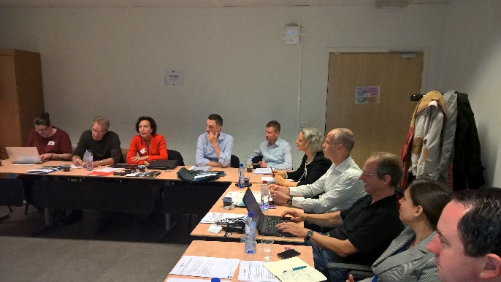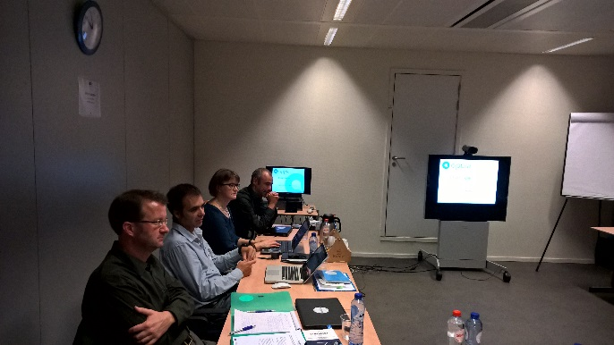

- Minutes from the 1st Meeting

The meeting starts with five overview presentations:
I) BB gives an overview on ESMERALDA and the aim of Milestone 31.
II) SR gives an overview on BISE:
- The two EEA staff members who were responsible for the content and IT development of BISE are not longer available; their replacement is expected
- The main focus of BISE is the BD strategy 2020, currently the midterm review report
- Graphs and data are maintained by the EEA Biodiversity Data Center (BDC)
- EU member state fact sheets are part of BISE, potential contribution from ESMERALDA here
- Biodiversity fact sheets for EU member states (EU28+)
- BISE catalogue/library
- MAES pages, official MAES WG materials, CICES
- Case study data base, interactive ecosystem type map (from EEA);
- How can BISE support ESMERALDA (and other way around)? Which data are/will be available and how can they be quality-checked (e.g. maps, ESMERALDA fact sheets)

III) MPS gives an overview on OPPLA:
- OPPLA is an online hub with different entry points
- The prototype is ready to be tested in autumn 2015
- Certain tools are available in the platform already
- Plan: quick response to requests “Ask OPPLA”, online market place, services
- Business plan foresees paid services to an independent company; in order to make OPPLA self-sustaining after the end of the projects (after 2017)

IV) ME gives an overview over EEA/ETC activities:
- No mandate yet to take up MAES in EIONET
- Links to national reference and European topic centres exist
- Mapping of ecosystem types, probability maps
- Maps integrated in new EEA data base (Version 2.1), labelled
- EEA is mapping environmental pressures over time, e.g. related to WFD, HNV, marine areas
- Impacts on habitats and biodiversity, relevant e.g. for BD strategy’s 15% targets
- New EEA report in 10/2015, collaboration with JRC about ES maps
V) JM presents the ESP Visualisation Tool:
- new version of ESP-VT to be launched in fall 2015
- ESMERALDA ES mapping case studies and review data will be uploaded
- JM is moderating all uploads as admin

Discussion

- Questions are discussed how closely ESMERALDA will/can be linked to OPPLA (e.g. related to EU Horizon 2020 Open Access strategy; quality check; ESP-VT maps; relation to BISE)
- Different options (first step: online links on different platforms; but much more detailed medium- and long-term strategies are needed. Real inter-operability possible? Technical issues need to be solved and contact points defined)
- Who are the key customers of the different platforms? Which data/information shall be fed to which platform (e.g. exchange information, event data, workshop information)
- Questions of data ownerships, technical questions, stakeholder demands need to be solved and adapted to the different environments
- ESMERALDA is committed to EC (DG RTD) and needs to deliver to MAES and BISE/EEA; BISE would need more funding to achieve DG ENV policy targets in relation to MAES
- Perhaps some changes in BISE are needed (stakeholder feedback, also from MAES – iterative process)
- OPPLA and BISE are considered as complementary systems; the level of integration needs to be further discussed. Can there be clear protocols for both platforms’ application?
- ESMERALDA can test different systems within its Workshops to identify stakeholder demands
- Consensus that no new platform shall be created!
- EU INSPIRE guideline on data sharing: JRC is working on it (2016)
- What can be reached until the next meeting?

Preliminary conclusions

1. Given that ESMERALDA is a direct support action to Action 5 of the EU Biodiversity Strategy, BISE seems the most evident platform to share results of the project. This is particularly relevant for information sanctioned by the Member States e.g., fact sheets, mapping guidance and maps (through interoperability with the ESPVT)
2. OPPLA may be a suitable platform to share guidance (the flexible mapping approach) but further insights are needed to understand the business model of OPPLA in order to ensure that ESMERALDA products can be made publically available at no cost.

Next meeting
The next meeting will take place either in March 2016 in Brussels (back-to-back with the MAES WG meeting) or in April 2016 in Nottingham (together with the ESMERALDA Workshop).

