Engagement plan for collaboration, networking and synergies
Milestone 10

21/09/2015

Joachim Maes

JRC

Dissemination level
Restricted

ESMERALDA
Enhancing ecosystem services mapping for policy and decision making
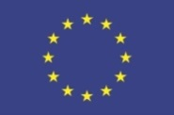
Table of contents

Preface 3
1. Action 5 of the EU Biodiversity Strategy: stakeholders 3
2. From support groups to communities of practice 5
3. Engagement plan 8

Preface

Milestone 10 relates to work carried out in Task 2.3: Network development. Based on an assessment of existing co-operation networks and collaborative activities, a new network of co-operation for in mapping and assessment implementation will be created. Feasible links with other relevant networks and platforms - such as ESP, IPBES, TEEB, SGA, IUCN-CEM, ALTER-Net, LTER, IALE - will be developed. In addition, existing related projects and initiatives (their initial plans and actual outcomes) will be scanned. Stakeholders (including relevant stakeholders from policy, management, science involved in ES mapping and assessment) will be encouraged to commit and mobilise themselves to the ES mapping and assessment process(es) by providing them information, focused (thematic, biome or region-related) examples and knowledge about funding opportunities. Mapping and assessment offer also business opportunities, which is why the business sector will be engaged in the network. Task 2.3 works in close collaboration with WP6 (Dissemination & Knowledge exchange).

Action 5 of the EU Biodiversity Strategy: stakeholders

Action 5 of the EU Biodiversity Strategy creates the knowledge base to support policy on green infrastructure, ecosystem restoration and no net loss of biodiversity and ecosystem services at EU scale. To kick off the discussion on what are the most important stakeholders for ESMERALDA, we need to understand who are the different actors involved in the implementation of Action 5 and who will be the potential users of the information generated under Action 5.

Different actors are involved in the (legal) implementation of Action 5 (Figure 1):

- The working group MAES on mapping and assessment of ecosystems and their services officially oversees the implementation of Action 5. It consists of member state representatives, staff working at EU institutions and further experts. The working group updates the Commission on the state of implementation in the different countries as well as at EU level and provides working guidance (see Figure 1).
- Several EU institutions implement MAES at EU level by mapping and assessing ecosystems and their services making use of pan-European data and models. The most important institutions are the European Environment Agency (EEA), the Joint Research Centre (JRC), and the Directorate Generals (DGs) of Environment (DG ENV) and Research and Innovation (DG RTD). DG RTD is not only supporting Action 5 through ESMERALDA, but will operationalise ecosystem services using the concept of nature based solutions. Since 2015, also Eurostat has become engaged (through INCA, Integrated system of National Capital Accounts).
- Action 5 needs to be implemented at the national level, so EU Member States have started the implementation as required by the Strategy (see also ESMERALDA member state fact sheets).

Different users will use results and outputs of Action 5.

- At global level. ESMERALDA (until 2018) and MAES (until 2020) coincide with the regional as well as thematic and methodological IPBES assessments. The European and Central Asia IPBES assessment is expected to deliver a first draft in the spring of 2016. This means that the flexible mapping and assessment methodology which ESMERALDA is developing will not be available for the first assessment, but ESMERALDA can contribute to capacity building processes organised by IPBES (e.g. through BES-Net). Clearly, there are several synergies between MAES and IPBES (e.g., EMSMERALDA partners are authors of the regional assessment) but establishing formal collaboration between these two initiatives is not a task as such for the project.
- At EU level there is interest from several commission services in MAES and Action 5. Above all, the knowledge base generated under MAES is expected to be the prior input to Actions 6 and 7 of the strategy. These relate to the deployment of green infrastructure, the restoration of 15% of degraded ecosystems and the no net loss initiative. In concert, these actions should warrant meeting target 2 of the strategy (maintaining or enhancing ecosystem services). Better information of ecosystem properties, functions, conditions and services is also expected to contribute to thematic environmental policy on nature (Natura 2000 with the Habitats and Birds Directives), air, water (Water Framework Directive), energy, or land. Also the new research programme on nature based solutions (under Horizon 2020) will be a key user of the MAES knowledge base. This is illustrated by the interest of different policy DG's of the Commission in collaborating with the MAES pilots: ecosystem specific of thematic case studies on mapping and assessment in agricultural land, forest, freshwater ecosystems, marine ecosystems, or urban areas.
- At Member State level. A key development is the usage of consistent and updated information of ecosystems to guide the EU Semester process. The European Semester is the EU's annual cycle of economic policy guidance and surveillance. Ultimately, this guidance would also include natural capital and should be based on the best available information and indicators. Different member states (but especially those countries which have recently finished an assessment) are now starting to use MAES in their national policies. One example is Spain which is drafting a new biodiversity strategy. Other examples are the implementation of policies on Green Infrastructure (e.g. in Flanders) which is dependent on MAES outputs.
- At regional and local level. Much of the spatial planning takes place at regional or local scale requiring detailed ES maps. Increasing interest in natural capital accounting by businesses, communities, and municipalities also drive the demand for MAES type of information.

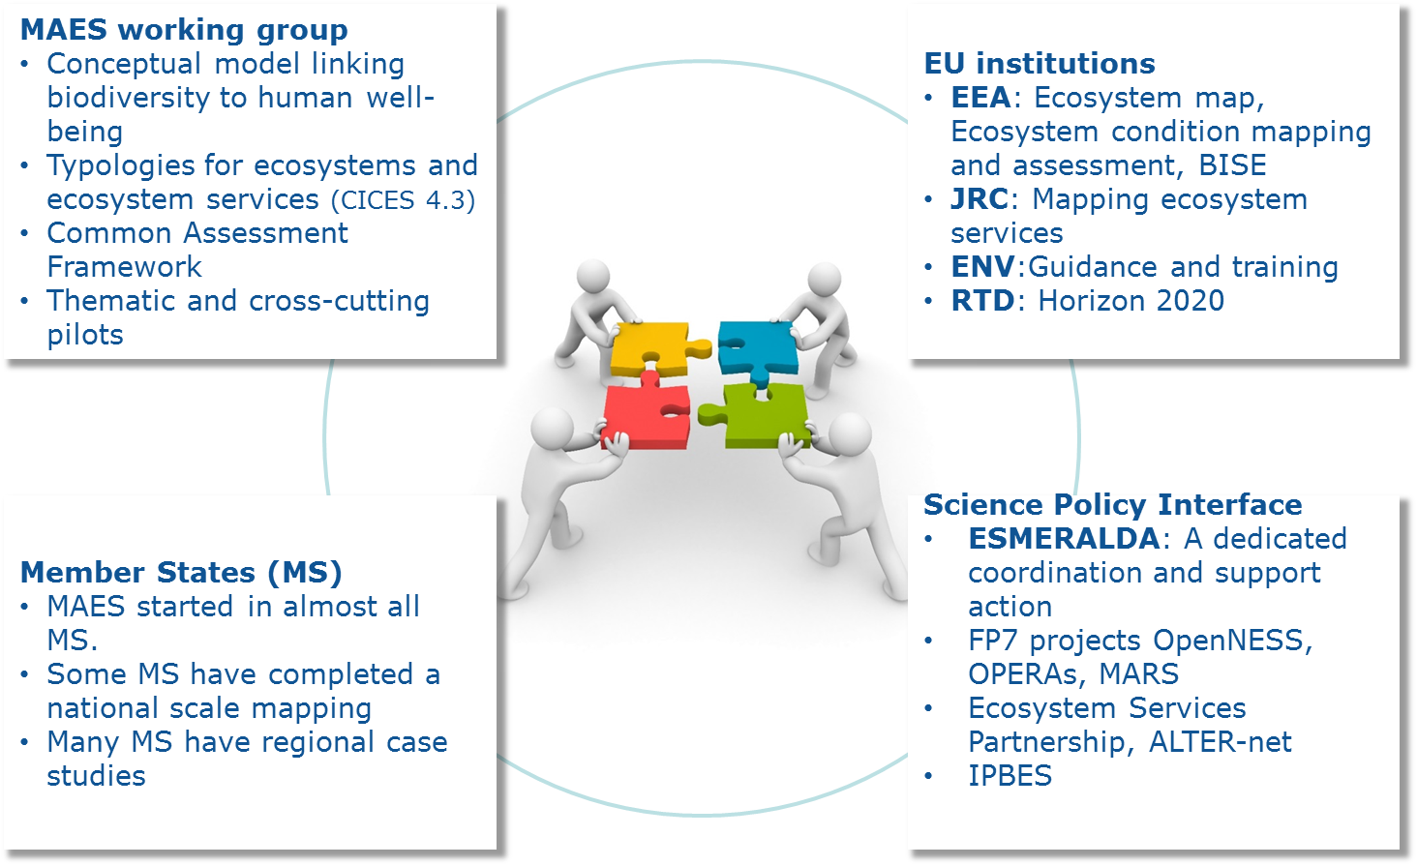

Figure 1. Different actors which are involved in the implementation of Action 5 of the EU biodiversity strategy to 2020.
- At thematic level. ESMERALDA (and in particular the workshops) are designed to provide thematic users with mapping and assessment methodologies. This is particularly relevant for decisions which affect the use of natural resources (e.g., forestry, agriculture but also conservation)

Regardless scale or theme, EU policies which have an important impact on land use, climate and environment, including agricultural and regional policy, will be users of ecosystem data.

A closer analysis of the different actors (who implement Action 5) and possible or future users (who will apply the knowledge base) shows that they group into three main roles (Figure 2): researchers (science), policy/decision makers, public policy officers or civil servants (policy), and practitioners (practice). Furthermore, the type of stakeholder will change during the course of the project following the MAES implementation cycle. The first phase of ESMERALDA will mainly work with those people who are responsible for implementing MAES at national levels, while towards the end of the project, increasing participation from people who use the knowledge base is expected.

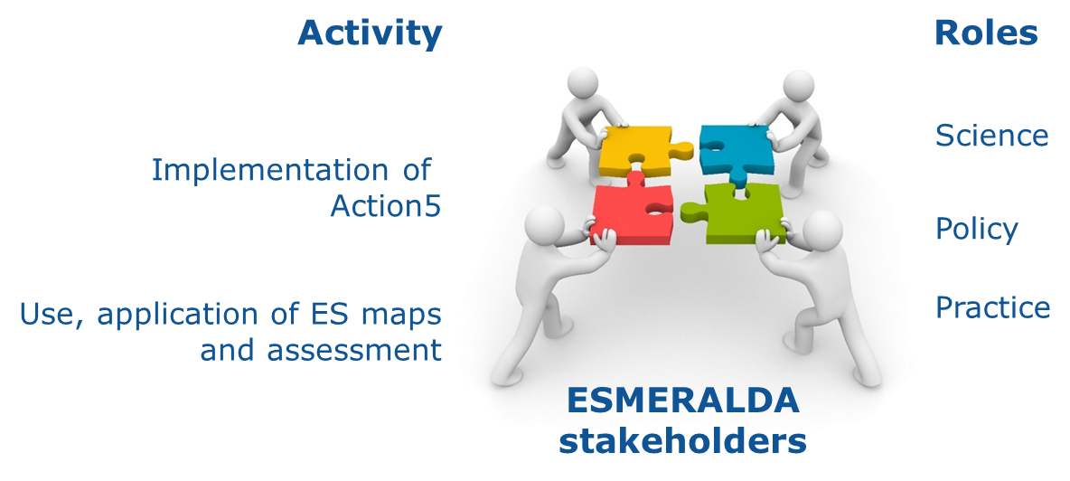
Figure 2. Stakeholder types of ESMERALDA. Stakeholders can be classified into six types depending on their role and activity.

From support groups to communities of practice

Providing enhanced mapping methods and models or assessment tools only one of the necessary steps for the implementation of Action 5. ESMERALDA can effectively build on a great deal of existing scientific capacity and knowledge. The main challenge will be to mainstream biodiversity and ecosystem services into all levels of decision-making (policies, plans, programmes and projects), as well as economic accounting/reporting. This requires awareness raising and capacity building in all member states, at different scales, and among the different stakeholders. It also requires building ownership of the MAES process which is set up as a collaboration among researchers, civil servants at EU and national levels officials, and other stakeholders. With ownership, we mean that Action 5 should not be seen as something that is imposed top down by the European Commission but that Action 5 and MAES is perceived as important at local and regional scales. Ultimately, these stakeholders find each other in a lasting community of practice that will help contribute to improve the knowledge.

In preparation of the ESMERALDA stakeholder workshop taking place from 14 to 16 October 2015, a set of European/national/local stakeholders has been identified, hereby drawing on the existing network of the working group MAES and the different spin off activities. Together with the ESMERALDA partners, these stakeholders are considered as a first support group (supporting stakeholder groups). Their essential task is to help ESMERALDA make a profile of each member state (as regards implementation of Action 5), to review the fact sheets, to help with the gap analysis, and, importantly to identify potential private and public users within their countries.

Communities of practice already exist at regional, national and global scales. In our context, a community of practice is a group of people sharing their knowledge on ecosystem services with each other and also other interested actors. The goal is to learn from each other’s experiences. This can be done through meetings but also by maintaining a website or by using social media. Examples are given in Table 1. Establishing these communities across Europe to improve knowledge is a goal of the MAES working group (2nd MAES report).

Table 1. Examples of already established communities of practice related to ecosystem services.

Regional or national scale
ESCOM  (Ecosystem Service Community Scotland) | Scotland |  | Supporting collaboration between science, policy and practice to better manage Scotland’s natural resources. | http://escom.scot/
Natural Capital Initiative | UK |  | Supporting decision-making that results in the sustainable management of our natural capital based on sound science. | http://www.naturalcapitalinitiative.org.uk/
The Belgium Ecosystem Services (BEES) network | Belgium |  | A community of practice aiming to connect different societal actors involved in ecosystem services research, practice and policy-making | http://www.beescommunity.be/
APEP | Portugal |  | The Portuguese branch of IALE has started a first meeting which can lead to a CoP on ecosystem services in Portugal
Community of Practice Ecosysteem-diensten | Netherlands |  | Encouraging ES professionals to share their experiences on the practical implementation of ecosystem services | http://www.rwsleefomgeving.nl/  organisatie/bodemplus/netwerken  /community-practice/
National Networks of the Ecosystem Services Partnership | Austria, Belgium, Croatia, France, Greece, Italy, Macedonia, Malta, Montenegro, Netherlands Poland, Portugal, Serbia, Spain, Switzerland, Turkey |  | National Networks aim to provide a Platform to exchange information and experiences with ecosystem services assessment and implementation at National levels. | http://www.es-partnership.org/esp/79346/5/0/50
Global scale
Sub-Global Assessment Network (SGAN) |  | A community of practice that connects and supports individuals and organisations involved in ecosystem assessments at regional, sub-regional, national and sub-national levels. |  | http://ecosystemassessments.net/
Ecosystem Services Partnership (ESP) |  | A worldwide network to enhance the science and practical application of  ecosystem services assessment |  | www.es-partnership.org
Natural Capital Project |  | The Natural Capital Project (NatCap) aims to integrate the values of nature into all major decisions affecting the environment and human well-being. NatCap develops simple, use-driven approaches to valuing nature, works closely with decision makers, and provides free, open source ecosystem service software tools to a broad community of users. |  | http://www.naturalcapitalproject.org/

Engagement plan

ESMERALDA is committed to establish under Milestone 13 supporting stakeholder groups in each member state. These groups are currently composed based on the contact lists of the working group MAES as well as the TRAIN and MESEU contracts which both support DG ENV with implementing Action 5. This information has been updated continuously based on feedback from stakeholders during the work carried out in ESMERALDA Tasks 2.1 and 2.2. These support groups are important to help define the needs which member states have to comply with Action 5 but ultimately, the success of Action 5 depends on how well the knowledge base developed by the member states and the EU is actually used to support decisions. Stakeholder engagement, awareness raising and dialogue remain crucial tools to achieve the objectives of Action 5.

Step 1. Establishing support groups (Milestone 13).
- What? This work is currently undertaken by WP2. Official establishment of support groups will be kicked off at the stakeholder meeting in Riga in October 2015.
- Who? SYKE and JRC have initialized this action. All project partners need to engage with stakeholders of their country, act as a link between them and the project, and participate in the support group of their country. Partners need to update all changes in stakeholder contact information to SYKE/WP2, which maintains a list consisting of contact information of stakeholders in all EU member states, other European countries and Israel.
- When? Support groups are to be established in all member states by 31/12/2015.

Step 2a. Inventory of existing initiatives at regional or national scale.
- What? Besides the communities of practice listed in Table 2, other networks or initiatives available in the different member states are to be inventoried.
- Who? All project partners have to report national networks or initiatives which may facilitate discussions on the implementation and usage of MAES.
- When? Announcement to be made at the stakeholder meeting. Inventory ready 30/11/2015

Step 2b. Inventory of existing initiatives at EU and global scale
- What? Besides the global communities of practice listed in Table 2, what other networks or initiatives are available to which ESMERALDA can contribute or which would be users of ESMERALDA products.
- Who? WP2 (JRC, WCMC, REC).
- When? Inventory ready 30/11/2015.

Step 3. Planning phase
- What? Analysis of the present initiatives and proposal for supporting the development of national networks in EU Member States. The analysis should make proposals targeting ESMERALDA partners which can play an active role in network development. ESMERALDA could see how to connect to the biodiversity and business platform of the European Commission. http://ec.europa.eu/environment/biodiversity/business/index_en.htm
- Who? FSD (ESP) to prepare an outline/working guidance on the options and possibilities to create ESP-NN’s as a community of practice on ecosystem services based on the capacity of ESP to support the development of national networks.
WCMC to make a proposal for a strategy for the project to approach IPBES and the SGAN.
- When? 31/01/2016.

Step 4a Network development in the EU Member States
- What? Support the development of national communities of practice which can help implement Action 5.
- Who? The engagement of ESMERALDA partners in all countries as well as of the support groups is important in this process.
- When? Starting in 2016 with follow up during the ESMERALDA Workshops.

Step 4b Teaming up with European or global initiatives
- What? Link ESMERALDA with European or global initiatives (in particular for promoting the mapping and assessment methodologies). Of particular relevance are the ESP European Chapter and at global level, IPBES, GEO BON and SGAN.
- Who? JRC, WCMC, and the ESMERALDA Executive Board.
- When? Starting in 2016 with follow up during the ESMERALDA Workshops.

Step 4c Networking with the business sector
- What? Understanding the best approach for communicating ESMERALDA outputs with relevant businesses/sectors.
- Who? SYKE? Anyone who is involved in the Biodiversity and Business platform?
- When? Special attention will be paid to this activity in preparation of Workshop 8 (03/2018) dedicated to address businesses and citizens.

Step 5. Business plan to sustain the network beyond ESMERALDA (Deliverable 2.5)

This step relates closely to Milestone 31 (inter-operability of ESMERALDA outputs into OpenNESS/OPERAs Common Platform and BISE). The Executive Board negotiates with BISE and OPPLA to see how ESMERALDA outputs can be part of one (or both) of these platforms. Note that OPPLA has formulated ambitions which overlap or correspond with those of other projects and initiatives such as ESMERALDA and ESP.

We suggest measuring the success of stakeholder engagement for the purpose of MAES and ESMERALDA simply as the number of Member States in which support groups or communities of practice have been established.

